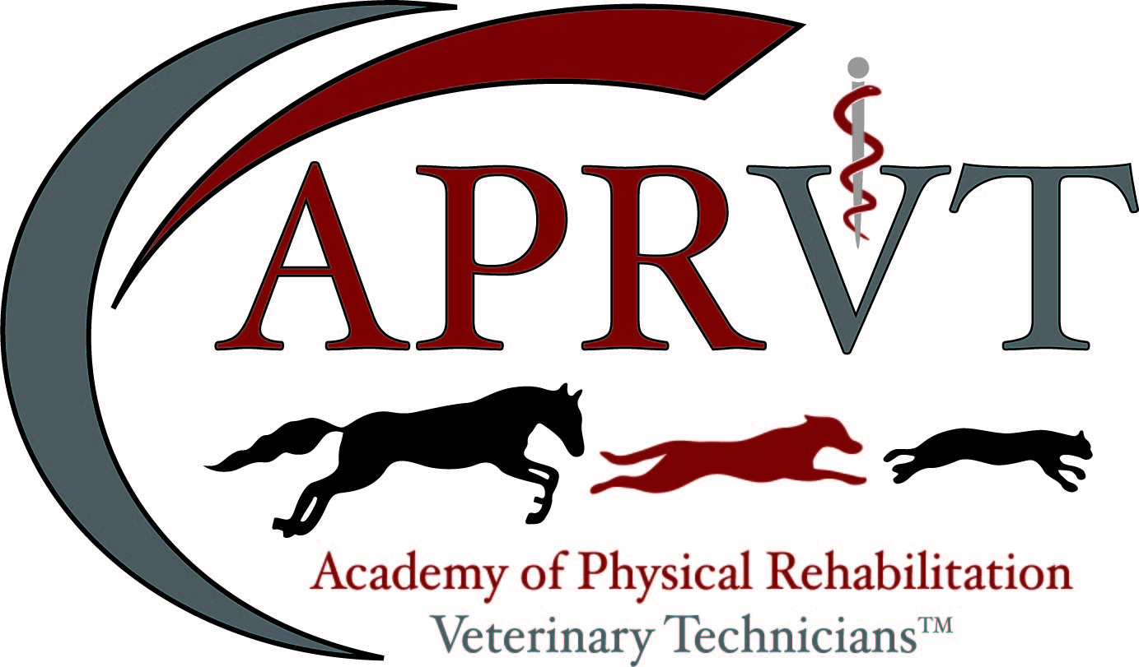

Mentor Program

Updated 6/2023

Welcome

The Academy of Physical Rehabilitation Veterinary Technicians (APRVT) is proud to endorse a mentorship program for prospective applicants working towards a Veterinary Technician Specialist recognition in Physical Rehabilitation. Becoming an exceptionally recognized expert in any field of study is a large step in one’s professional career and carries with it responsibility and integrity to uphold the values of the membership organization. The APRVT values the importance of a veterinarian mentor for the prospective applicant and recognizes the need for mentorship regarding application submission expectations beyond clinical skills and acquisition of case logs/reports that a veterinarian mentor provides.

The purpose of the mentor is to guide and evaluate the mentee through the process of the submission of application materials. Mentors must be familiar with the current APRVT application requirements and each mentor needs to obtain a current copy of the application packet to ensure that they are participating using the same materials as the applicant for the examination year being applied. Mentors are encouraged to outline a plan to accomplish the mentorship and communicate the structure of the mentorship to the applicant. Both the mentor and mentee should agree upon the planned outline and make individual changes to meet one another’s needs.

To become a mentor, e-mail APRVTApplications@Gmail.com

Mentor Requirements
- Be a member in good standing with the APRVT of at least one (1) year duration.
- Charter members may only become a mentor if a Chair position has not been held on the Credentialing Committee for one (1) year duration of last term.
  - Presidents, Vice Presidents, and Immediate Past-Presidents shall not be mentors.
  - Committee members may become a mentor but shall not be members of the Exam or Credentialing committees.
- Agree to the APRVT confidentiality agreement and release of liability.

Mentor Expectations
- Time is given gratuitously. Mentors are not to receive financial compensation for assisting a mentee.
- Mentoring an applicant shall be a minimum of six (6) months prior to final application submission. Should the mentor be unable to continue, the mentee and APRVT shall be notified immediately of such change.
- Mentor with final application preparation. Assistance with examination preparation is not part of the mentor program.
- Provide at least quarterly communication with the mentee regarding application progress with one final check-in no later than December 1st (Applications are due January 1st!). Providing guidance at the last minute is unprofessional and not helpful for the mentee.
- Maintain confidentiality and exhibit a professional, unbiased relationship with the mentee at all times.

Mentor Expectations (continued)
- Provide honest and constructive criticism or feedback.
- Mentors shall receive credits towards recertification renewals only if written communications are maintained as proof of mentoring a mentee. An example may include a log with chronological dates, duration of time spent, and a description of activities completed.

Mentee Requirements
- Successful approval of a Pre-Application 1 year prior to full Application deadline.
- Qualified to apply for the APRVT Application within the following year (e.g. applicants shall not utilize a mentor if they will not be qualified to submit an application for more than one year).
- Notify the APRVT within thirty (30) days, in writing, of a mentor request (mentors are not automatically assigned) after an application has been rejected.
- Maintain confidentiality of the mentor and application materials.
- Exhibit a professional, unbiased relationship with the mentor at all times.
- Agree to the APRVT confidentiality agreement and release of liability.
- Communicate clearly with the mentor on a minimum of a quarterly basis.
- Be understanding that mentors are providing time gratuitously and are likely working full time as well.
Mentee Expectations
- Mentees may - on their own - recruit more than one mentor if desired. The APRVT will only assign one mentor to each candidate upon request.
- Mentees shall be financially responsible for any travel, lodging, or per diem necessary to meet with a mentor should it become necessary.
- Mentees cannot use mentor time to complete the skills list or obtain case logs as required by the application requirements. In the circumstance the mentee and mentor work in the same environment, both parties shall notify their employer of intent and shall not interfere with regular work duties for patient care.
- Mentees shall not hold mentors liable for errors or omissions should an application fail. It is ultimately the applicant’s responsibility to understand where deficiencies lie.

What are Mentors able to assist a Mentee with?
- Assistance with grammar and spelling for the general application
- Overall presentation of application.
- Assist with ensuring completeness of final materials checklist (e.g. including membership numbers, certificates of attendance).
- Suggestions for Continuing Education opportunities following the APRVT Continuing Education requirements.
- Suggested reading materials for study or referencing.
- Review of Case Logs in the capacity of fulfilling the submission guidelines (e.g. word count, appropriate use of acronyms, skill number is claimed, complete signalment history).
- Review of Case Reports in the capacity of fulfilling formatting, domains, and critical thinking skills.
- Preparation for the examination in the sense of general test-taking techniques, calming techniques, and other strategies for reducing test anxiety.
- Preparation for the examination with material the mentee has prepared (e.g. prepared flash cards, questions about a particular domain task).

What are Mentors NOT able to assist Mentee’s with?
- Discuss types of specific questions on the examination.
- Sharing of a mentor’s previous application grading rubric including comments from the credentialing committee.
- Sharing of any private communication from a credentialing, examination or otherwise committee person regarding the mentor’s application or pre-application.
- Complete revisions of Case Reports or Case Logs.

Required Forms

The following documents shall remain on file prior to mentorship commencement. Failure to submit signed copied may result in rejection of a mentor request.

1. Waiver – Mentee and Mentor
2. Non-disclosure agreement – Mentee and Mentor

Forms are to be submitted to aprvtapplications@gmail.com
Subject line: MENTOR PROGRAM <Applicant Name><Exam Year>

Mentorship Request Form

Current Date: <Month, Day, Year>

Dear Credentialing Chairperson,

This letter is being submitted as a formal request for an APRVT approved mentor to assist with my final submission of application packet materials.

My application for acceptance was previously submitted on <Insert Date> and was rejected for the <Insert Exam Cycle Year>. I am working towards re-submission of application materials by <Insert Deadline>.

I have included the following required signed attachments:

  - Waiver

  - Non-disclosure Agreement

Thank you for your consideration and time.

Applicant Name:

Applicant E-Mail Contact:

Applicant Phone Contact:

Waiver

I (the Mentee) hereby submit my credentials to the Academy of Physical Rehabilitation Veterinary Technicians (APRVT) for consideration for mentoring by a VTS (Physical Rehabilitation) member in good standing in accordance with its rules and shall enclose the required application materials before due date deadlines or I am a member (the Mentor) in good standing and have agreed to gratuitously participate in a mentor program. I agree that prior to or subsequent to review of my application by a mentor or prior to reviewing a mentee application; the APRVT Executive Board may investigate my standing as a credentialed veterinary technician or VTS, including my reputation for complying with the standards of ethics of the profession. I understand as a mentee that mentors are submitting their time gratuitously and shall be held harmless should my application be rejected by the credentialing committee.

I (Mentee and Mentor) agree to abide by the decisions of the Executive Board and thereby voluntarily release, discharge, waive and relinquish any and all actions or causes of actions against the Academy of Physical Rehabilitation Veterinary Technicians and each and all of its members, officers, examiners and assigns from and against any liability whatsoever in respect of any decisions or acts that they may make in connection with this mentor review, re-application, application, examination, grades on such examinations and the granting or issuance, or failure thereof, of any certificate, except as specifically provided by the Constitution and Bylaws of this organization. I (Mentee and Mentor) agree to exempt and relieve, defend and indemnify, and hold harmless the Academy of Physical Rehabilitation Veterinary Technicians, and each and all of its members, officers, examiners and assigns against any and all claims, demands and/or proceedings, including court costs and attorney’s fees, brought by or prosecuted for my benefit, extended to all claims of every kind and nature whatsoever whether known or unknown at this time.

I (Mentee and Mentor) understand that as part of the application materials submitted or reviewed herewith, it is asked to suggest issues, questions and ideas, which the Academy of Physical Rehabilitation Veterinary Technicians can include in future development of Academy standards and processes. Therefore, Academy of Physical Rehabilitation Veterinary Technicians is herein signed all rights, titles and interest in and to any and all such issues, questions and ideas which may submitted to Academy of Physical Rehabilitation Veterinary Technicians now or in the future.

Mentees: I certify that all information provided by me on the application submitted herewith is true and correct. Initials: ______________
VTS (Physical Rehabilitation) Mentor: I acknowledge that I have read, understand and agree to abide by the terms and conditions stated above. Initials: ________________

Full name of signee and title(s):
Date:

Mentor-Mentee Non-Disclosure Agreement

THIS AGREEMENT is made and entered into as of (date)______________ by and between ____________________, an officially recognized mentor for the Academy of Physical Rehabilitation Veterinary Technicians (APRVT) and member in good standing, (the “disclosing party”), located at 10807 Kuykendahl Rd. Suite 406, The Woodlands ,Texas 77382 and ______________________________ (the “mentee” or “recipient”).

This agreement is entered into pursuant to non- disclosure of information. Recipient shall be acting as VTS (Physical Rehabilitation) candidate. Throughout the duration of this Agreement, the Disclosing Party may deem it necessary to disclose or share certain information with the recipient. Therefore, in consideration of this agreement both parties agree to as follows:

CONFIDENTIAL INFORMATION
For all intents and purposes of this Agreement, “Confidential Information” shall mean or include any information that is deemed proprietary to the Disclosing Party and that which is not generally known to the public, whether in tangible or intangible form, whenever and however disclosed, including but not limited to:
- business plans
- performance results or status of the mentee
- proprietary application results, formulations or decisions
- any other information that the Disclosing Party may deem confidential. This includes any and all public domain sites (Facebook, Instagram, Twitter etc.)

The recipient may disclose information concerning their own status of membership or application but no information of any other members or prospective members within the APRVT without their express written and mutual consent. The disclosing party shall not engage in dispersal of personal information for purposes such as study or work groups unless express permission is received from the recipient, and in such case the APRVT shall not moderate such a group unless specifically sponsored or endorsed by the APRVT. The disclosing party is not to distribute personal information, of any kind, which may affect the “recipient” or “mentee” employment status.

I, the “recipient” or “mentee”, authorize release of the following information to the “disclosing party”:
Name and Email Address for purposes of creating a mentorship, managed solely by prospective candidates and their mentor
Full application, results and recommendations

IN WITNESS WHEREOF, the parties hereto have executed this Agreement as of the aforementioned date.

“Mentee or Recipient” Full Name and Title:_______________________________________
“Disclosing Party” (signed representative): ________________________________________

DATE: ___________________________________

